**Jenkins setup in Windows**

**Install Jenkins : -**

1. Download and install the latest Jenkins for Windows (jenkins-1.572.exe) from <http://mirrors.jenkins-ci.org/windows/jenkins-1.572.zip>
2. Create an environment variable *Jenkins_Home* with value *path \to\Jenkins* and add it to the PATH variable

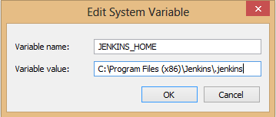

1. open a browser and launch url *<system IP>:8080* and Jenkins dashboard page should be opened

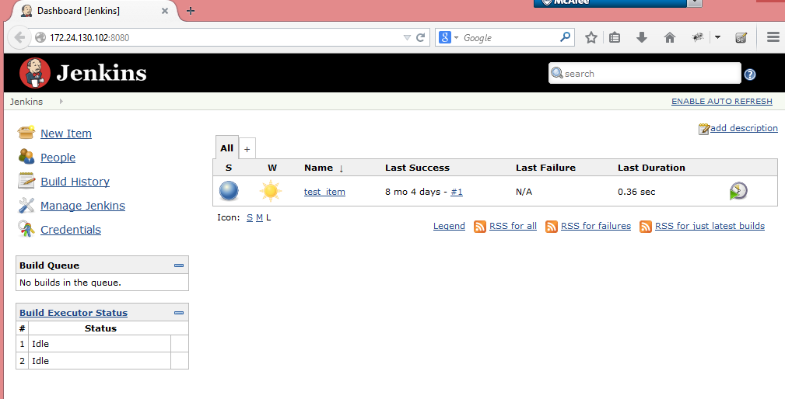

**Configure a new Node :**

1. Launch Jenkins and go to the computer page by launching the url *<system IP>:8080/computer*
2. Click the ‘*New Node’* link to add a new node (a node here refers to the machine where Jenkins execution will be done)

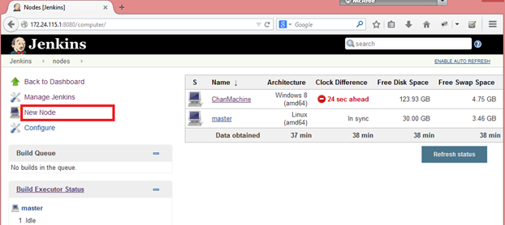

1. Give a name for the Node and select ‘*Dumb Salve’* option and then click ‘*Ok*’ button

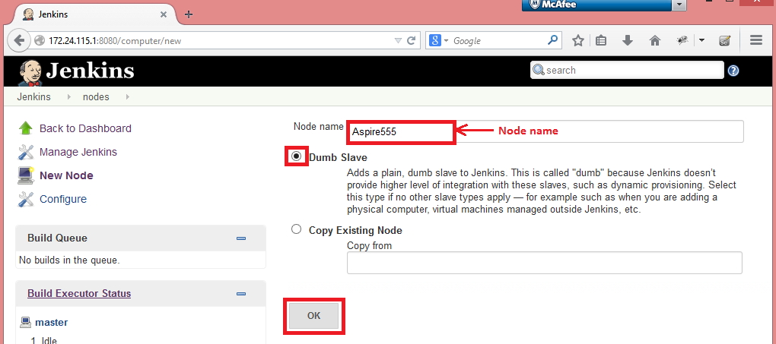

1. Fill the mandatory fields for the node and click ‘*Save*’ button

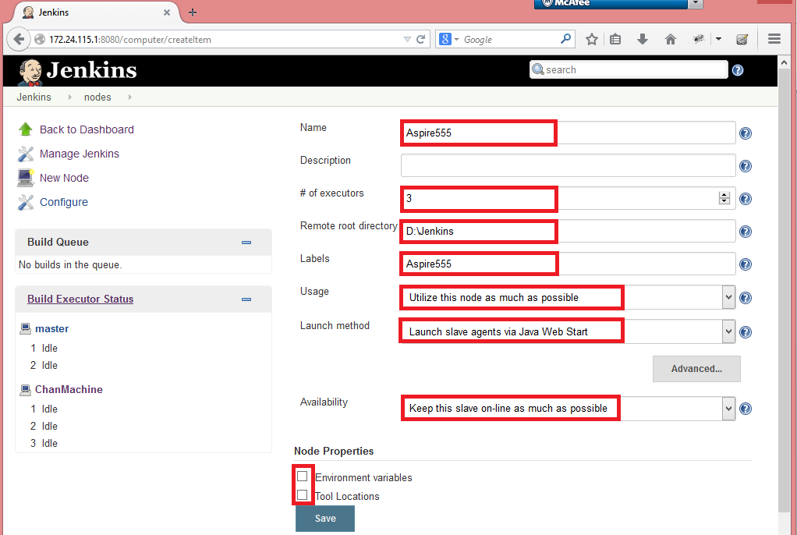

1. Now the new node will be listed with a cross mark denoting that it is not connected

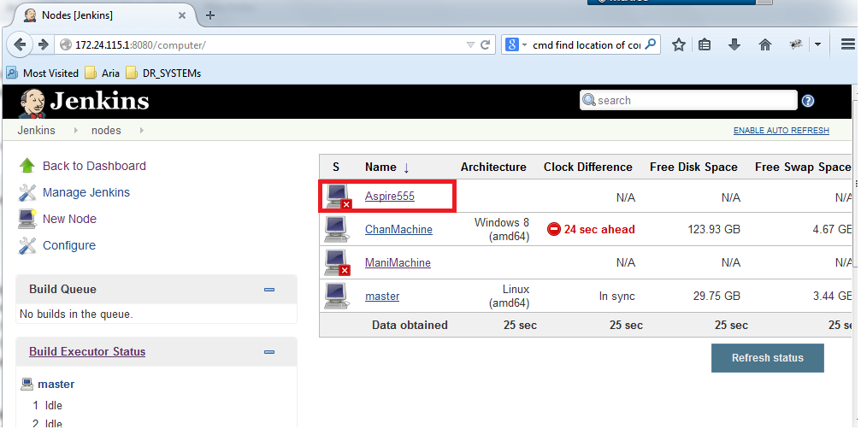

1. Click on node link (*Aspire555*), the salve machine config page will be displayed. Click on the ‘*Launch’* button and a jar file (named ‘*slave-agent’*) will be downloaded, run the jar file to connect to Jenkins server (a small Jenkins slave agent window will be opened)

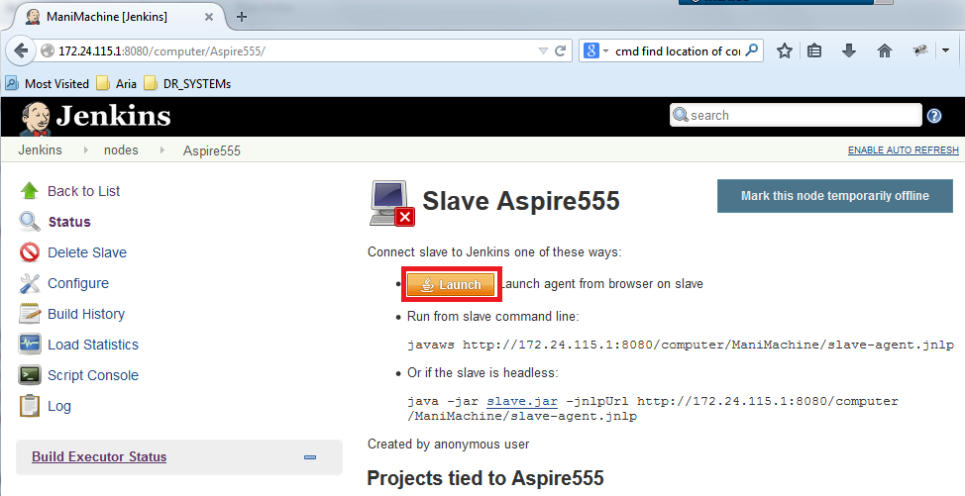

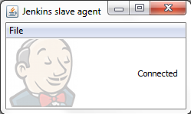

**Setup cucumber in Jenkins :**

1. Launch Jenkins and go to *Manage Jenkins >> Manage Plugins >> Available* and select cucumber plugins and click ‘*Install without restart’* button

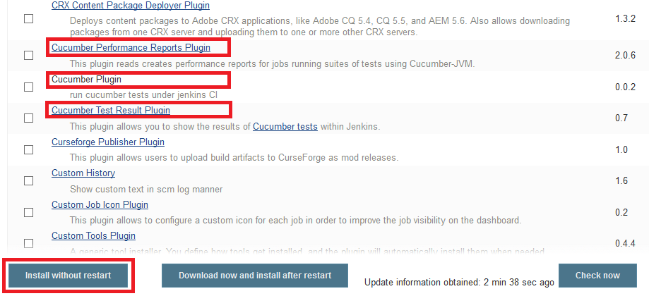

1. The plugins will installed one-by-one

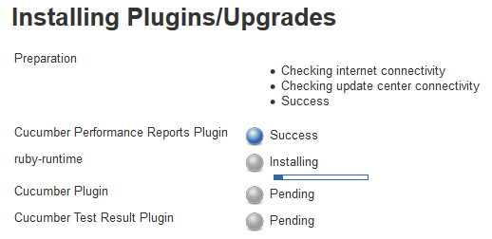

1. After installation manually relaunch the Jenkins (by closing and reopening the browser)

Note : In case if the download/installation of plugin fails, manually install the plugin by downloading it from the given url and placing it under *<Jenkins installation path>\plugins* and restarting Jenkins.

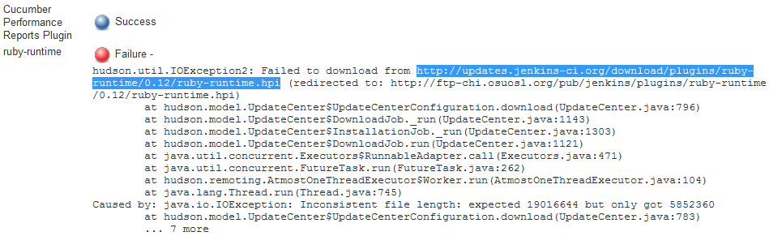

**Creating a new job :**

1. Launch Jenkins and click ‘*New Item’* link and fill the job name and select ‘*Free style project’* option and click ‘*Ok’* button

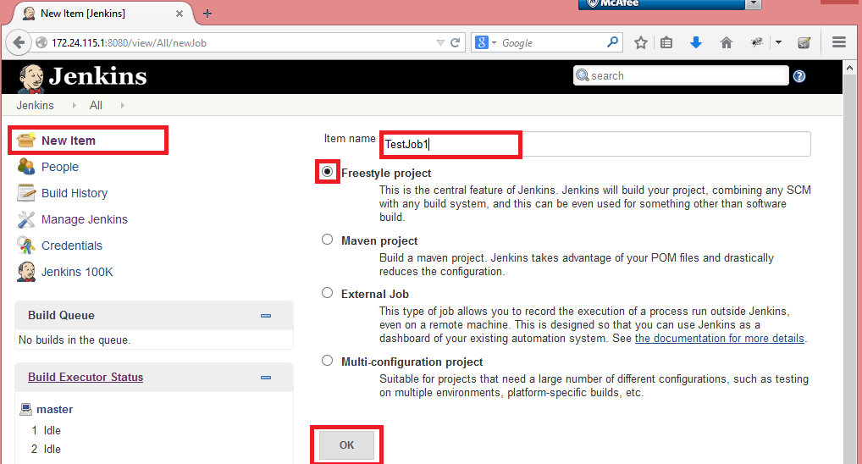

1. Fill the node name under ‘*Restrict where this project can be run’* option – this job will run only the mentioned node

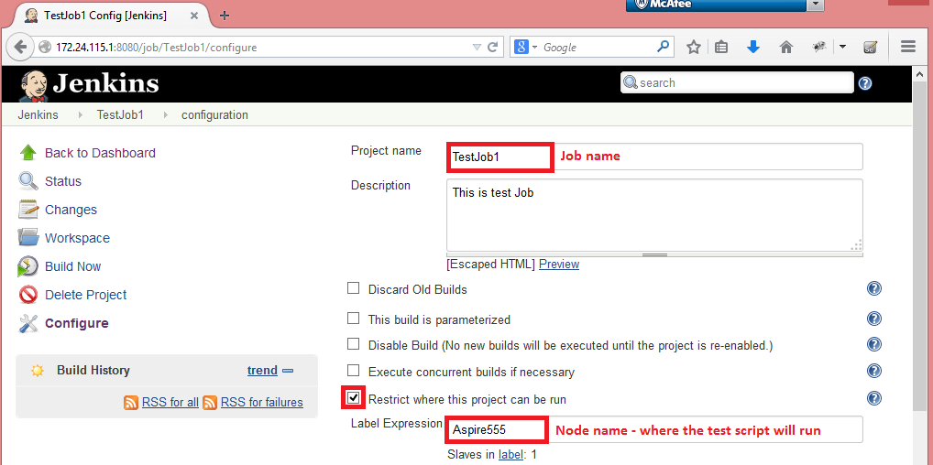

1. Now fill the source code repository. Select ‘*Subversion’* option and fill the repository url.

Note : if ‘*unable to access repository’* error is thrown, then click ‘*enter credentails’* link and fill the credentials for that repository and it will show ‘*Authentication was successful. Information is stored in Jenkins now.*’ if the credentials are valid else credential error message will be shown

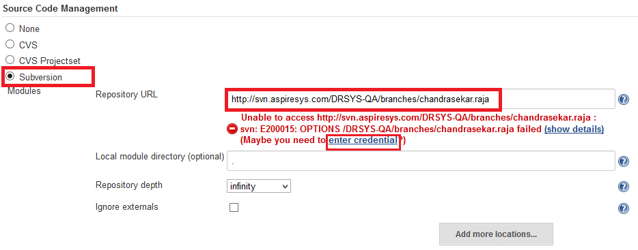

1. Under Build section. Hover ‘*Add build step’* button and select ‘*Execute Windows Batch Command’* option and fill the TAF directory path and cucumber command in Command option

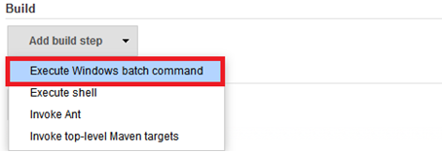

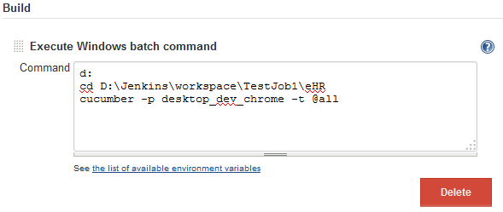

1. Under Post-build Actions. Hover ‘*Add post-biuld action’* button and select ‘*Publish cucumber results as a report’* option

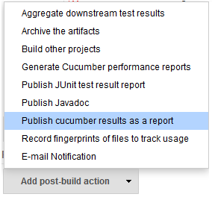

Click the ‘*Advanced…*’ button and fill Json Reports Path field with the test report directory (here its ‘*eHR\test_result’*)

1. That’s all. Click the ‘*Save’* button. Click the ‘*Build Now’* link to run the job.